INFOSYS CRYPTO VOLATILITY AND RISK ANALYSER

INTERNS NAME : Brijendra
Aniket
Nishitha
BATCH NO : 10
MENTOR NAME : Sophiya
TEAM : B
INTERNSHIP DURATION: 40 DAYS

Table of Contents

• Problem Statement
• Abstract
• Introduction
• Objectives
• Existing System
• Proposed System
• System Architecture
• Tech Stack Used
• Installation Steps
• How to Run
• Features
• Conclusion
• References
• Future Scope

Problem Statement

Cryptocurrency markets are highly volatile, making it difficult for investors to assess risk and make informed decisions. Existing platforms often provide raw price data without clear risk analysis or visualization. To address this challenge, the Crypto Volatility and Risk Analyzer is designed to fetch real-time and historical cryptocurrency data, calculate key risk metrics such as volatility, Sharpe ratio, and beta coefficient, and present insights through interactive visual dashboards. This system helps users identify high-risk and low-risk cryptocurrencies in a clear and data-driven manner.

Abstract

The Crypto Volatility and Risk Analyzer is a data-driven system designed to analyze and visualize the risk associated with cryptocurrency price movements. The project fetches real-time and historical crypto market data using APIs and computes key financial metrics such as volatility, Sharpe ratio, and beta coefficient. Interactive visual dashboards are used to present risk insights clearly, enabling users to compare cryptocurrencies and identify high-risk and low-risk assets. This tool supports informed decision-making for investors, traders, and researchers through accurate and visual risk analysis.

Introduction

The Infosys Internship Program commenced with a structured learning phase aimed at equipping interns with essential programming knowledge. The initial sessions were designed to introduce Python programming, which is widely used in modern software development, data analysis, and automation. These sessions helped interns become familiar with the basic concepts of programming and understand how Python can be applied to solve real-world problems efficiently.
During the training period, emphasis was placed on building a strong foundation in Python by covering fundamental topics such as syntax, data types, string operations, numeric computations, and basic programming logic. The sessions were conducted in a step-by-step manner to ensure that interns with varying levels of prior knowledge could follow along comfortably. Practical examples and hands-on exercises were included to improve understanding and boost confidence in writing and executing Python programs.
The knowledge gained during these introductory sessions plays a crucial role in preparing interns for project-based learning. The concepts learned form the backbone for understanding advanced topics and implementing the assigned project, Crypto Volatility and Risk Analyser. This report provides a detailed overview of the training sessions attended and highlights the learning outcomes achieved, reflecting the skills and understanding developed throughout the internship.

Objectives

• To collect real-time and historical cryptocurrency price data using APIs such as CoinGecko or Binance.
• To analyze cryptocurrency price movements by calculating volatility, Sharpe ratio, and beta coefficient.
• To visualize risk and return trends using interactive charts and dashboards.
• To classify cryptocurrencies into low-risk, medium-risk, and high-risk categories based on computed metrics.
• To provide a data-driven decision support tool for investors and researchers to assess cryptocurrency risk.

Existing System

• Most cryptocurrency platforms provide raw price data, historical trends, or basic charts.
• Users often rely on external tools or manual calculations to assess volatility and risk.
• There is limited real-time risk analysis, and few platforms classify cryptocurrencies based on risk levels.
• Investors may struggle to compare multiple cryptocurrencies effectively and make informed decisions

Proposed System

• The Crypto Volatility and Risk Analyzer automatically fetches real-time and historical cryptocurrency data from APIs.
• Computes key risk metrics including volatility, Sharpe ratio, and beta coefficient.
• Provides interactive visual dashboards to compare multiple cryptocurrencies.
• Classifies cryptocurrencies into low, medium, and high-risk categories.
• Offers actionable insights to help investors and researchers make informed decisions based on data-driven analysis.

System Architecture
The system architecture of the Crypto Volatility and Risk Analyzer is designed to handle real-time and historical cryptocurrency data, perform risk analysis, and present actionable insights through interactive dashboards. It consists of four main modules :
- Data Acquisition Module
Fetches live and historical cryptocurrency data from APIs such as CoinGecko and Binance.Handles missing values and formats data for further analysis.
- Data Processing Module
Computes essential risk metrics such as daily and annualized volatility, Sharpe ratio, and beta coefficient.Uses rolling window methods to track time-based variations in prices and risk.
- Visualization Module
Creates interactive visualizations using Python libraries like Plotly or Matplotlib.Displays price trends, volatility movements, and risk-return scatter plots in a dashboard format.
- Risk Classification and Reporting Module
Categorizes cryptocurrencies into Low-Risk, Medium-Risk, and High-Risk based on computed metrics.Generates summarized reports and visual exports (CSV, PNG, PDF) for decision support.
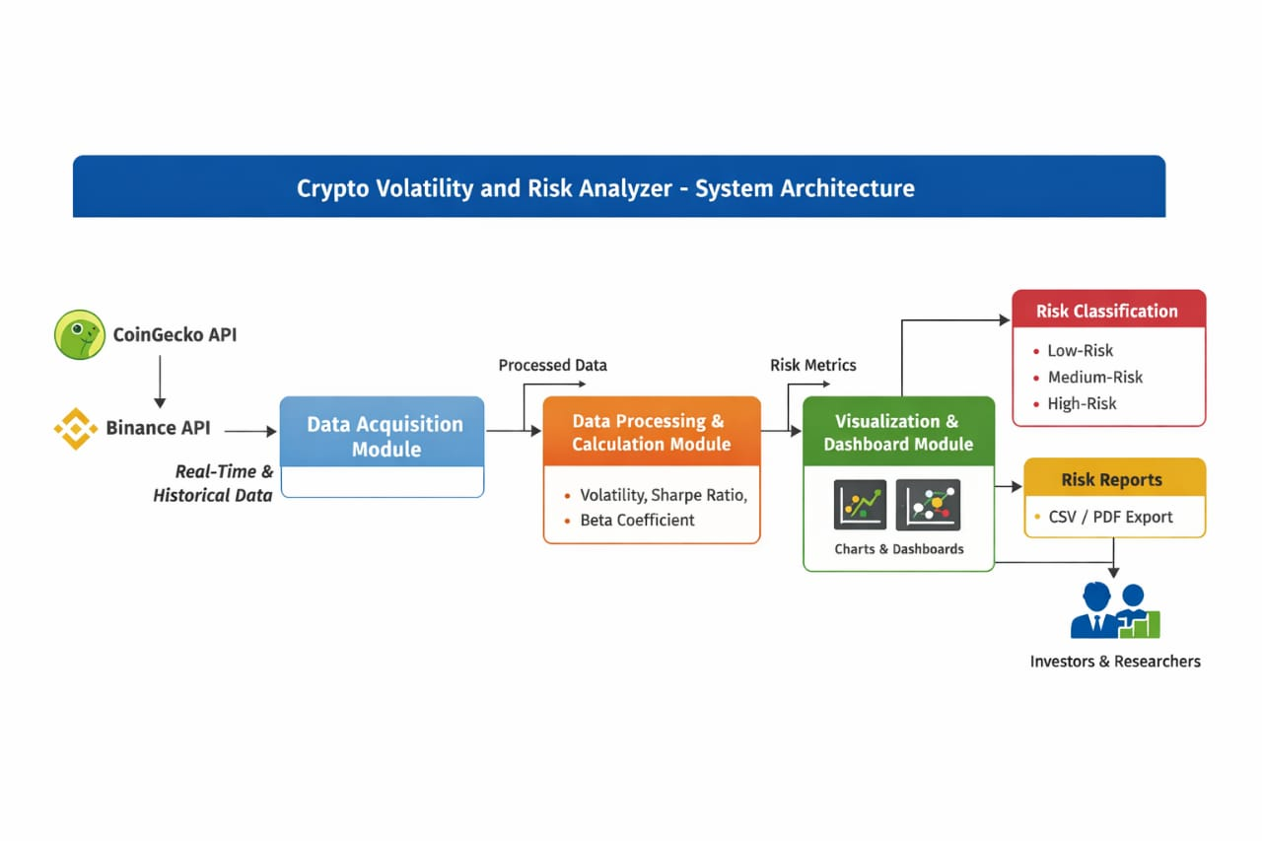
Data Flow:
• Data flows from the APIs into the Data Acquisition Module.
• Processed and calculated metrics are passed to the Visualization Module.
• Insights and classified risk levels are finally presented through the dashboard and reports for users to make informed decisions.

Tech Stack Used :

Programming Language
Python - Used for data fetching, processing, analysis, and visualization.
Data Handling & Analysis
Pandas – Data manipulation and time-series handling
NumPy – Numerical and statistical computations

API & Data Source
CoinGecko API / Binance API
Fetches real-time and historical cryptocurrency price data.

Data Visualization
Plotly – Interactive graphs and dashboards
Matplotlib – Static charts and basic visualizations

Dashboard / Web Framework
Streamlit / Dash
Used to build interactive analytical dashboards.

Development Tools
VS Code – Code editor
Git (optional) – Version control

Operating System
Windows / Linux

Installation Steps :

Step 1: System Setup
Install Python (version 3.9 or above) on the system.
Verify installation using:-
-----> Python --version

Step 2: Create Virtual Environment
Open terminal or command prompt.
Create a virtual environment:-
----->python -m venv venv
Activate the virtual environment:-
Windows: venv\Scripts\activate

Step 3: Install Required Libraries
Install project dependencies using pip:-
“pip install pandas numpy requests matplotlib plotly streamlit”

Step 4: API Configuration
If using Binance API:-
Create a Binance account.
Generate API key and secret.
Add API credentials in the configuration file.
If using CoinGecko API:
No API key required (public API)

Step 5: Project Setup
Download or clone the project source code.
Navigate to the project directory:-
“cd Crypto-Volatility-Risk-Analyzer”

Step 6: Run the Application
To run the dashboard:-
----->streamlit run app.py
(or run the main Python script if dashboard is not used)

Step 7: Access the Dashboard
Open browser and go to:-
----->http://localhost:8501
View interactive charts and risk analysis.
How to Run :-

Step 1: Open Project Folder
Open Command Prompt / Terminal.
Navigate to the project directory:-
“cd Crypto-Volatility-Risk-Analyzer”

Step 2: Activate Virtual Environment
Windows:
“venv\Scripts\activate”

Step 3: Run Milestone1
Step 4 : Run Milestone2

Step 5:Run Milestone 3

Step 6 : Run Milestone 4

Step 7: View Output

For Streamlit:-
Open browser and go to:
“http://localhost:8501”
View charts, risk metrics, and classifications.

Features :
Automatic Crypto Data Fetching
Retrieves real-time and historical cryptocurrency price data from APIs like CoinGecko or Binance.
Risk Metric Computation
Calculates volatility, Sharpe ratio, beta coefficient, and Value-at-Risk for accurate risk analysis.
Interactive Visualization Dashboard
Displays price trends, volatility graphs, and risk–return analysis using interactive charts.
Risk Categorization
Classifies cryptocurrencies into High-Risk, Medium-Risk, and Low-Risk categories based on computed metrics.
Decision Support for Investors
Helps users compare multiple cryptocurrencies visually to make informed investment decisions.
Conclusion :
The Crypto Volatility and Risk Analyzer provides a comprehensive, data-driven approach to understanding cryptocurrency market risks. By fetching real-time and historical data, calculating key financial metrics such as volatility, Sharpe ratio, and beta coefficient, and presenting insights through interactive dashboards, the system enables investors and researchers to make informed decisions.
The project successfully demonstrates how automated risk analysis and visualization can classify cryptocurrencies into low, medium, and high-risk categories, helping users identify safe investment opportunities and manage potential losses. Overall, this tool bridges the gap between raw market data and actionable investment insights, making cryptocurrency trading more transparent and reliable.

References :
• CoinGecko API Documentation – https://www.coingecko.com/en/api
• Binance API Documentation – https://binance-docs.github.io/apidocs/spot/en/
• Pandas Documentation – https://pandas.pydata.org/docs/
• NumPy Documentation – https://numpy.org/doc/
• Plotly Documentation – https://plotly.com/python/
• Dash Documentation – https://dash.plotly.com/
• Python Official Documentation – https://docs.python.org/3/
• Kaggle Datasets – Cryptocurrency Historical Data – https://www.kaggle.com/

Future Scope :

The Crypto Volatility and Risk Analyzer can be further enhanced in the following ways:
1.Integration of More Cryptocurrencies: Extend support to a larger set of cryptocurrencies, including stablecoins and emerging altcoins.
2.Real-Time Alerts: Implement notification systems to alert users about sudden volatility spikes or high-risk events.
3.AI and Machine Learning: Incorporate predictive models to forecast price movements and risk trends using historical data.
4.Portfolio Risk Analysis: Enable users to analyze multi-crypto portfolios and optimize risk-return trade-offs.
5.Mobile and Web Applications: Develop user-friendly mobile and web apps for broader accessibility and interactive dashboards.

